Women’s Clothing E-Commerce Review
By Stella (Juanru) Zhang (jz766)

Introduction

Online product reviews provide both structured and unstructured information. A single review may include a star rating, a recommendation decision, and written comments about fit, quality, comfort, or disappointment. Because of this, reviews can be used to study not only whether customers liked a product, but also how they described that experience.

A customer may like the color but dislike the fit, or praise the design while criticizing the fabric. A star rating alone cannot fully capture that kind of mixed evaluation, so the review text provides important additional information.

The goal of this project is to identify broad patterns in review language, examine whether reviews form distinct types, and determine which text patterns are associated with recommendation behavior.

The project is organized around a broad question: How do different features of customer reviews reveal the different types of reviews that exist, and how are those review types related to whether a product is recommended?

Data Cleaning and Preparation

The analysis uses the dataset “Womens Clothing E-Commerce Reviews.csv.” After loading the file, I created a cleaned review-level dataset containing review_id, Review Text, Rating, Recommended IND, Positive Feedback Count, Age, Department Name, word_count, and char_count. Reviews with missing or blank review text were removed. Text fields were converted to character format, numeric variables were converted to numeric format, and the recommendation indicator was recoded into a consistent binary variable.

A second dataset was created at the token level by splitting each review into individual words. Standard stop words were removed, along with missing tokens, numeric tokens, and tokens shorter than three characters. Additional clothing-specific words such as “dress,” “shirt,” “top,” and “pants,” as well as generic shopping words such as “buy” and “ordered,” were also removed so that the text analysis would focus more on evaluative language than on product category labels.

For the text modeling stage, I built a TF-IDF document-term matrix from the cleaned token data. The vocabulary was filtered so that only words appearing in at least 15 reviews and in no more than 30% of reviews were retained. The resulting matrix was row-normalized and then reduced to 40 latent dimensions using truncated SVD. Each review was therefore represented by 40 text-based features, labeled svd_1 through svd_40. These features were later used for clustering and logistic regression.
For the predictive modeling stage, the text features were constructed in a way that avoided data leakage. The reviews were divided into training and test sets before the final TF-IDF and SVD features were created. The TF-IDF vocabulary and inverse document frequency weights were learned only from the training reviews. The test reviews were then transformed using the vocabulary and weights learned from the training set.
This procedure is important because the test set should represent unseen data. If the full dataset were used to construct the TF-IDF vocabulary or SVD dimensions before the train-test split, information from the test set could influence the model indirectly. By fitting the text-processing steps only on the training set, the test-set evaluation more accurately reflects how the model would perform on new reviews.

EDA

The cleaned review-level dataset contained 22,641 reviews, with very little missing data. Only Department Name had missing values, and even there the missing rate was extremely small (13 reviews, or 0.06%). This indicates that the dataset was well suited for further analysis without major additional missing-data treatment.

The dataset was strongly imbalanced toward positive reviews. Over half of all reviews were 5-star reviews, and about 81.9% of all reviews were marked as recommended. This means that positive product experiences dominate the dataset overall. This imbalance is important for the later prediction task because a model can achieve high overall accuracy while still performing poorly on the smaller class of not-recommended reviews.
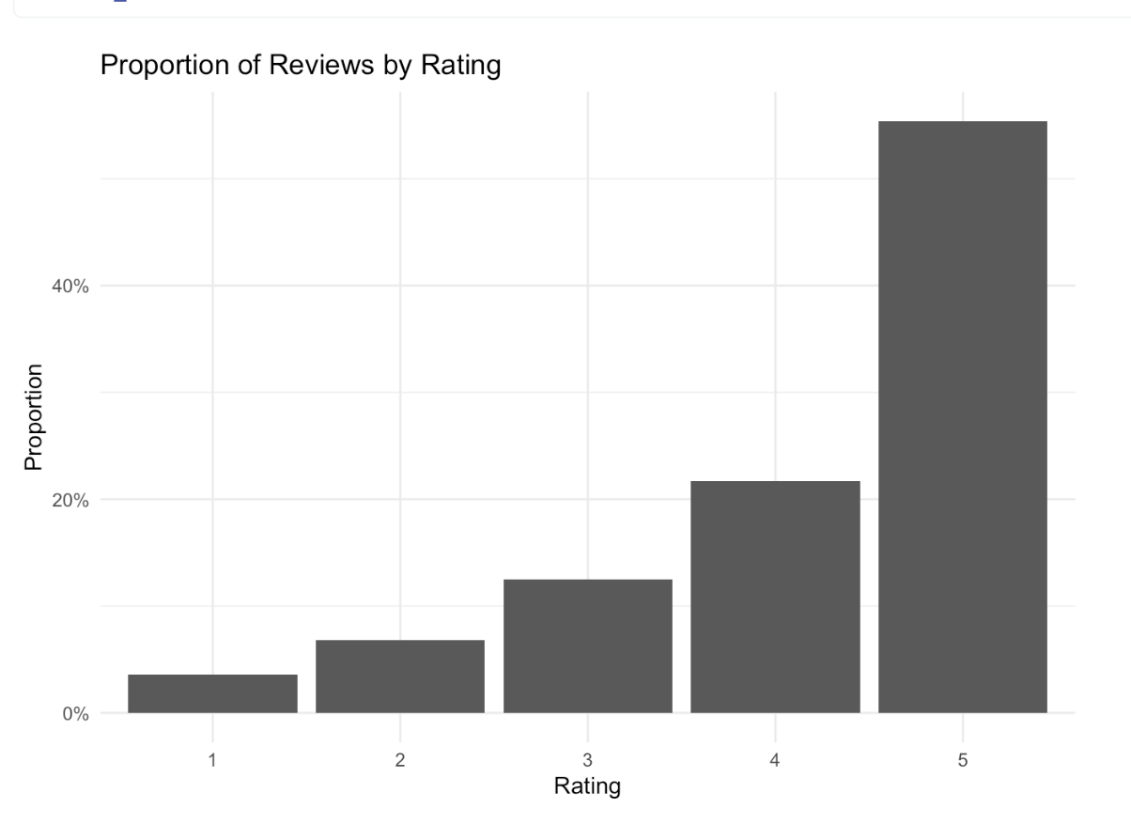
Grouped summaries by rating showed that review effort is not monotonic with satisfaction. Average word count rose from 58.80 words for 1-star reviews to 64.48 words for 3-star reviews, then declined to 58.20 words for 5-star reviews. This suggests that middling or mixed evaluations tend to generate longer explanations than the most favorable reviews, likely because customers feel a greater need to justify or qualify moderate experiences.
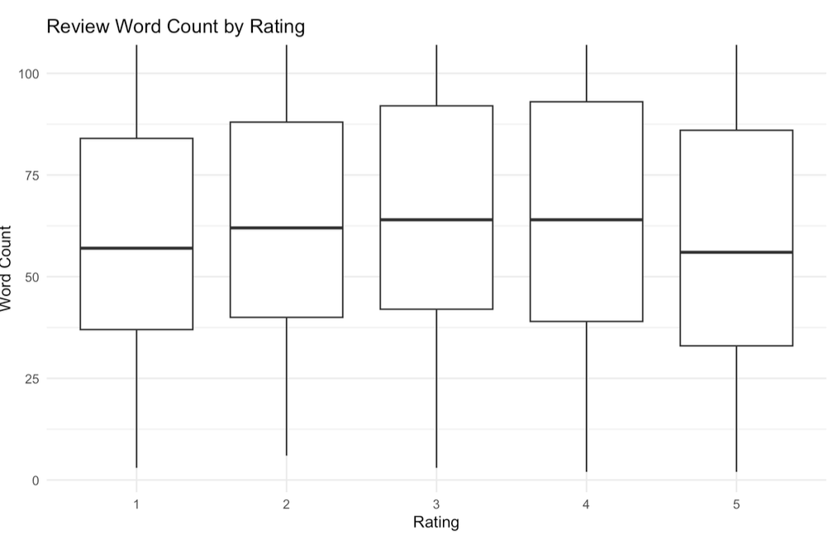

Recommendation rates also increased sharply with rating, from 1.83% among 1-star reviews to 99.82% among 5-star reviews, showing that the structured review fields were internally coherent even before text-derived sentiment features were added.
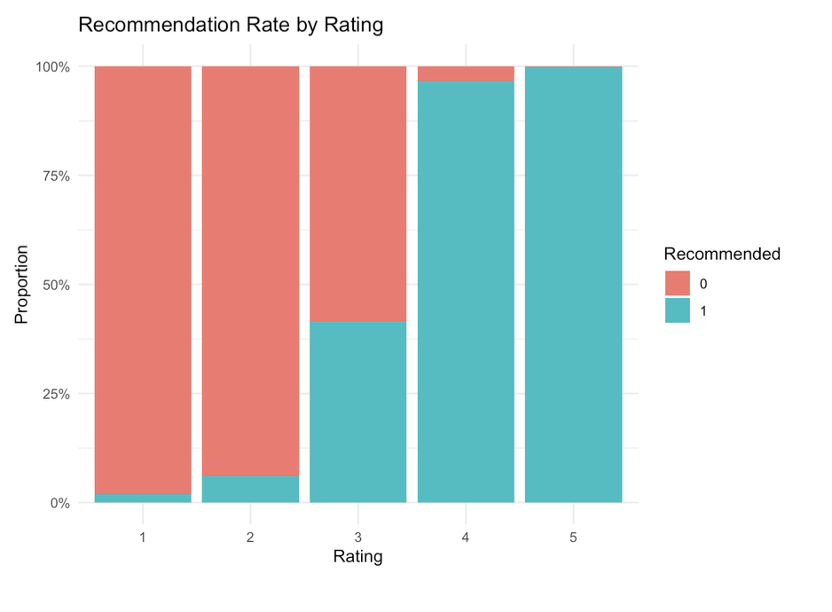

SVD and Structure Clustering
After creating the SVD text features, I used k-means clustering to identify recurring types of reviews. The clustering analysis was based only on the SVD text dimensions. Structured variables such as rating, recommendation status, age, department, review length, and positive feedback count were excluded from the clustering step. This ensured that the clusters were formed from review language rather than directly from review metadata.
I compared several clustering solutions, with particular attention to k = 4, k = 5, and k = 6. Because this part of the project is exploratory, the final choice of k was based on interpretability, coherence of distinctive words, and whether the resulting clusters represented substantively meaningful review types.

Main Clustering Result: k = 5
The k = 5 solution separated the review corpus into five major review types: negative/problem-focused reviews, style- or design-oriented reviews, detailed measurement/exchange reviews, fit-and-sizing guidance reviews, and price/value-focused reviews. These clusters differed in distinctive vocabulary, recommendation rate, average rating, review length, and feedback count. This suggests that review language reflects different modes of customer evaluation, not only different levels of satisfaction.
Review Type 1 was the clearest negative or problem-focused cluster. Its distinctive words included “stain,” “cleaned,” “shed,” “worst,” “lint,” and “needless.” These terms suggest dissatisfaction with product quality, garment care, or visible flaws. This cluster therefore represents reviews centered on defects, disappointment, and negative product experiences.
Review Type 2 was more style- and design-oriented. Its distinctive words included “romantic,” “shade,” “embroidered,” “lace,” “feminine,” “delicate,” “pink,” and “floral.” Although this language is not strongly negative, the cluster had a more moderate recommendation rate and average rating than the strongest positive clusters. This suggests that style-focused reviews often involved careful aesthetic evaluation rather than simple endorsement.
Review Type 3 represented detailed measurement and exchange-oriented reviews. It had the longest reviews and the highest average feedback count, indicating that these reviews may have been especially useful to other shoppers. Its distinctive words included “measurements,” “exchange,” “reference,” “sized,” “cup,” “looser,” and “weight.” This cluster appears to capture detailed fit troubleshooting and size-adjustment advice.
Review Type 4 was the clearest fit-and-sizing guidance cluster. It had a high recommendation rate and high average rating, and its distinctive words included “size,” “petite,” “true,” “regular,” “length,” “fit,” and “petites.” Unlike the more troubleshooting-oriented Type 3, this cluster focused more on practical fit confirmation, including whether the garment fit as expected or worked for particular body types.
Review Type 5 was a price- and value-focused cluster. Its distinctive words included “price,” “sale,” “steal,” “worth,” “paying,” “justify,” and “discount.” This cluster had a lower recommendation rate than the strongest positive clusters, suggesting that value language often appeared in more conditional evaluations. In these reviews, customers were not only judging whether the item looked good or fit well, but whether it was worth the cost.
Overall, the k = 5 solution indicates that clothing reviews are organized around recurring product concerns, including quality, fit, sizing, style, and value. These results support the argument that review text reveals the specific reasons behind customer evaluations rather than simply reproducing positive or negative sentiment.
Cluster summary plot for k=5.
This figure presents the final chosen clustering solution, which balances interpretability and detail.
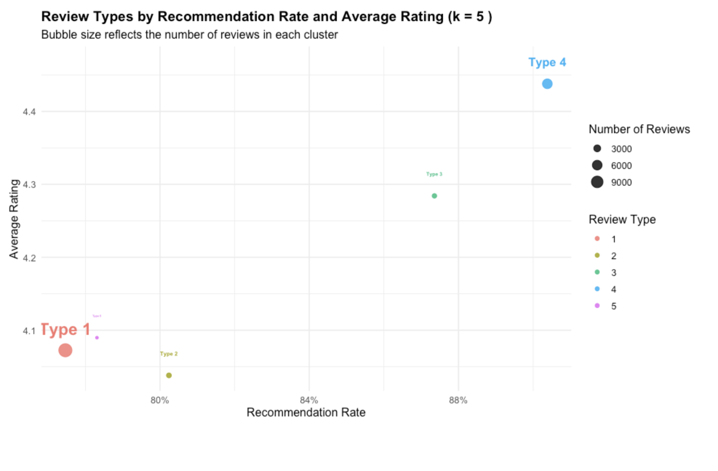

Distinctive words by cluster for k=5.
This figure shows the most cluster-specific vocabulary in the final chosen solution.
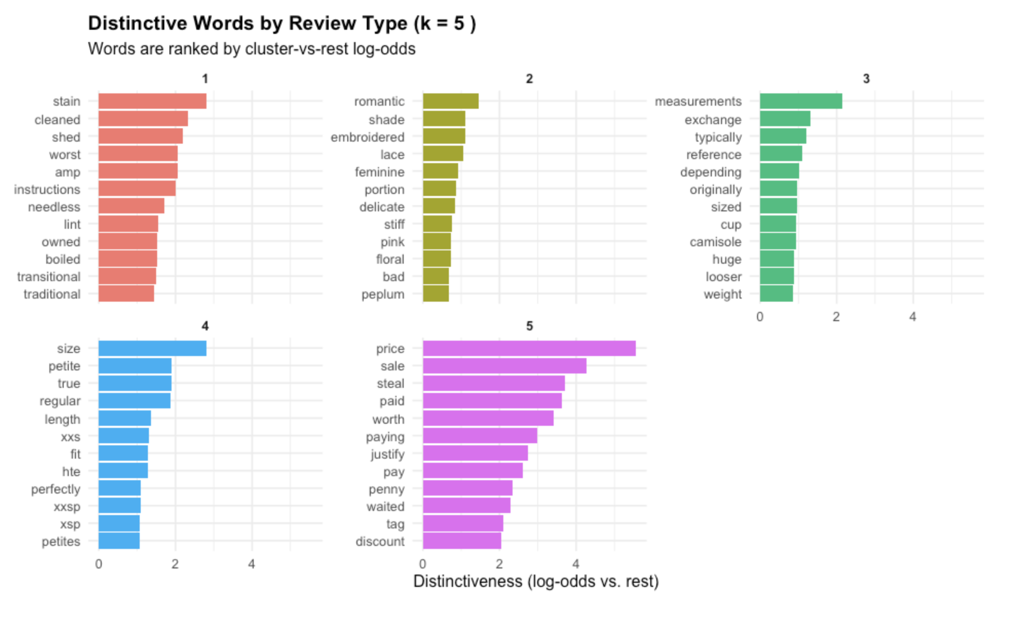

Comparison with k = 4 and k = 6
The k = 4 and k = 6 clustering solutions support the interpretation of the k = 5 result by showing similar review patterns at different levels of detail. The k = 4 solution produced broader clusters, including a negative/problem-focused group, a positive endorsement group, a fit-and-sizing group, and a longer practical-review group. This solution was relatively easy to interpret, but it grouped together some review styles that were more clearly separated in the k = 5 model.
The k = 6 solution produced a more detailed structure. It separated direct positive endorsement from occasion-based praise, and it distinguished general fit guidance from more specific exchange or fit-adjustment reviews. However, the additional detail made the results less concise and somewhat more fragmented.
For this reason, the k = 5 model was selected as the main clustering solution. It preserves the most important patterns found in both the broader k = 4 solution and the more detailed k = 6 solution, while remaining easier to summarize and interpret.

Cluster summary plot for k=4.
This figure shows the first meaningful subdivision of the favorable review space beyond the coarse k=3 solution.
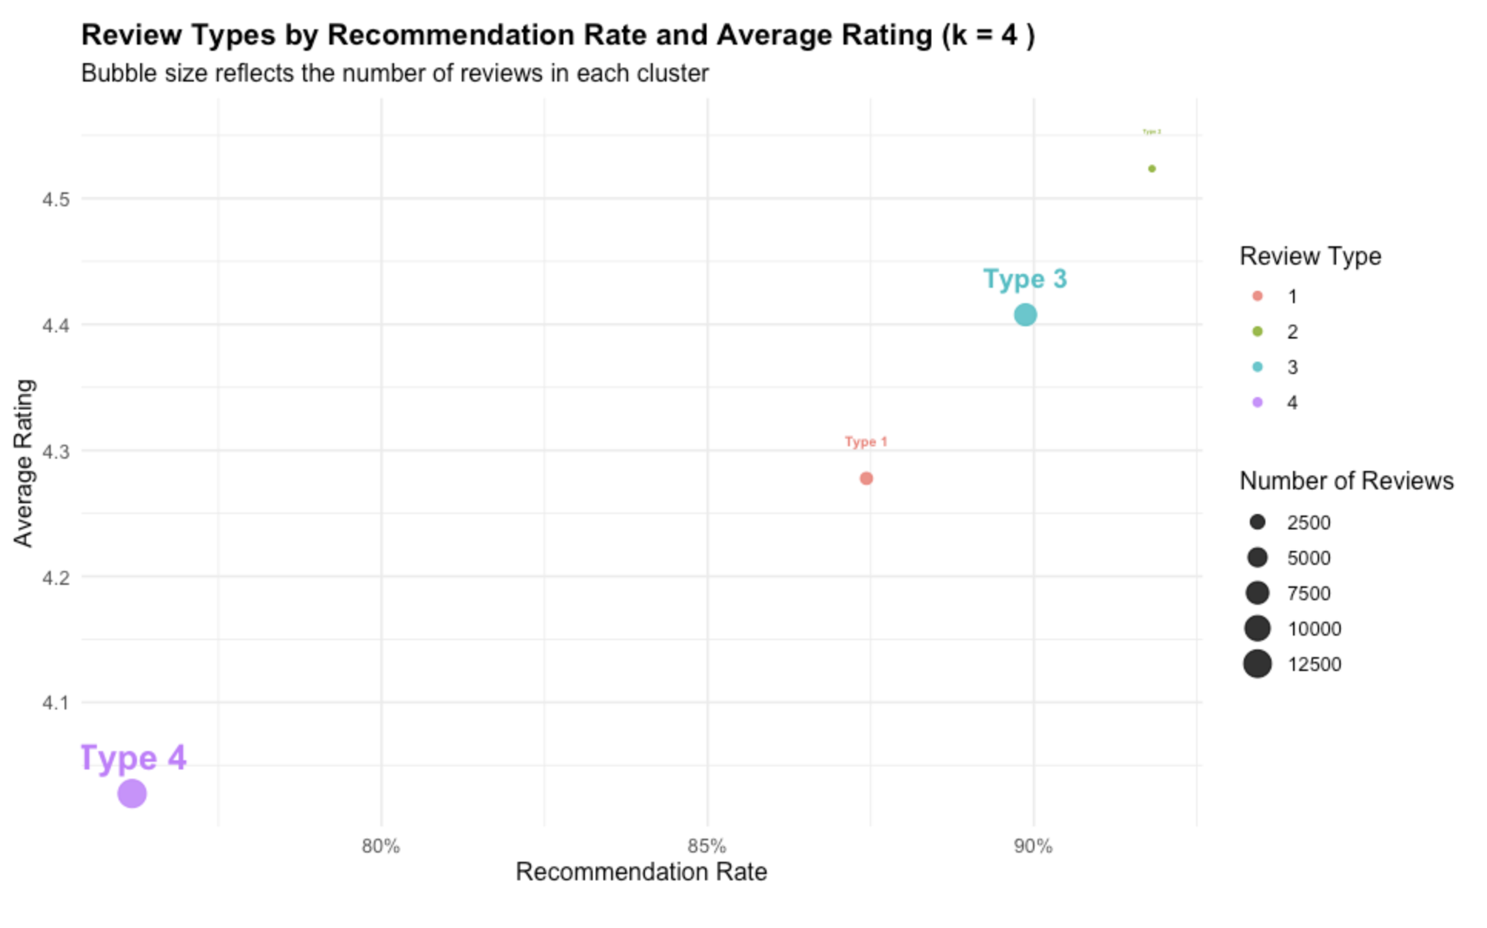

Distinctive words by cluster for k=4.
This figure highlights the words that most clearly distinguish the k=4 clusters from one another.
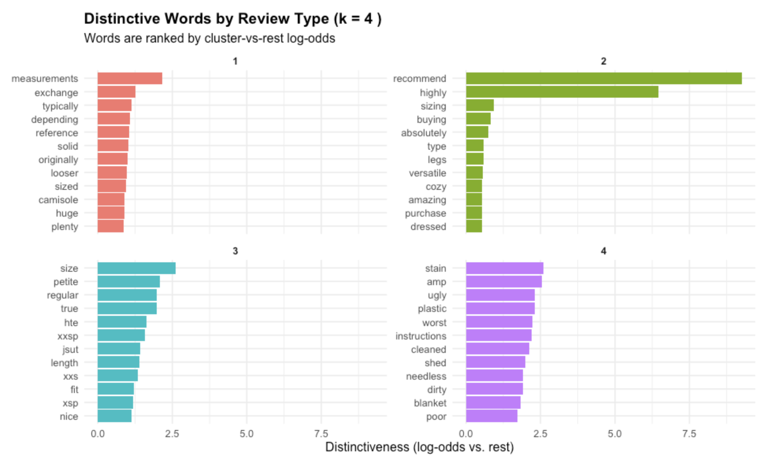

Cluster summary plot for k=6.
This figure illustrates the more refined clustering solution and helps assess whether the added detail is substantively useful.
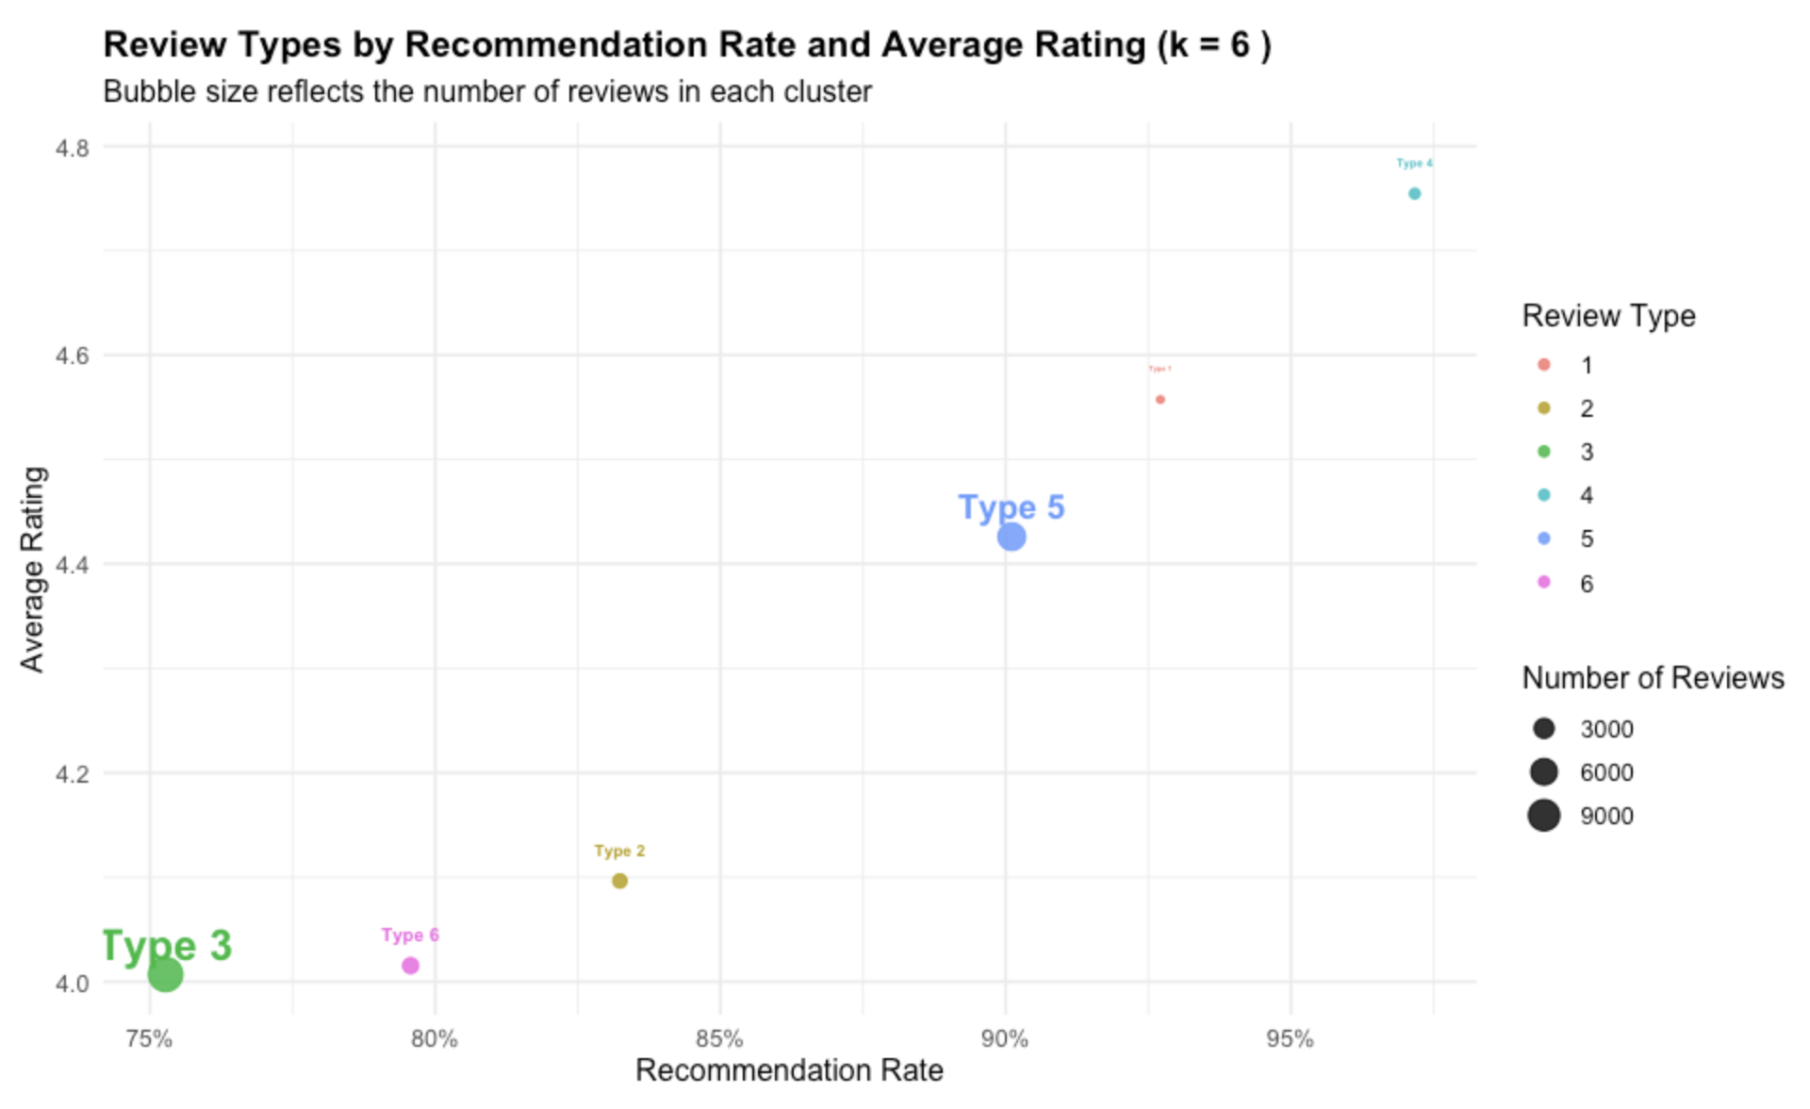

Distinctive words by cluster for k=6.
This figure helps determine whether the additional k=6 subgroup has a coherent lexical identity.
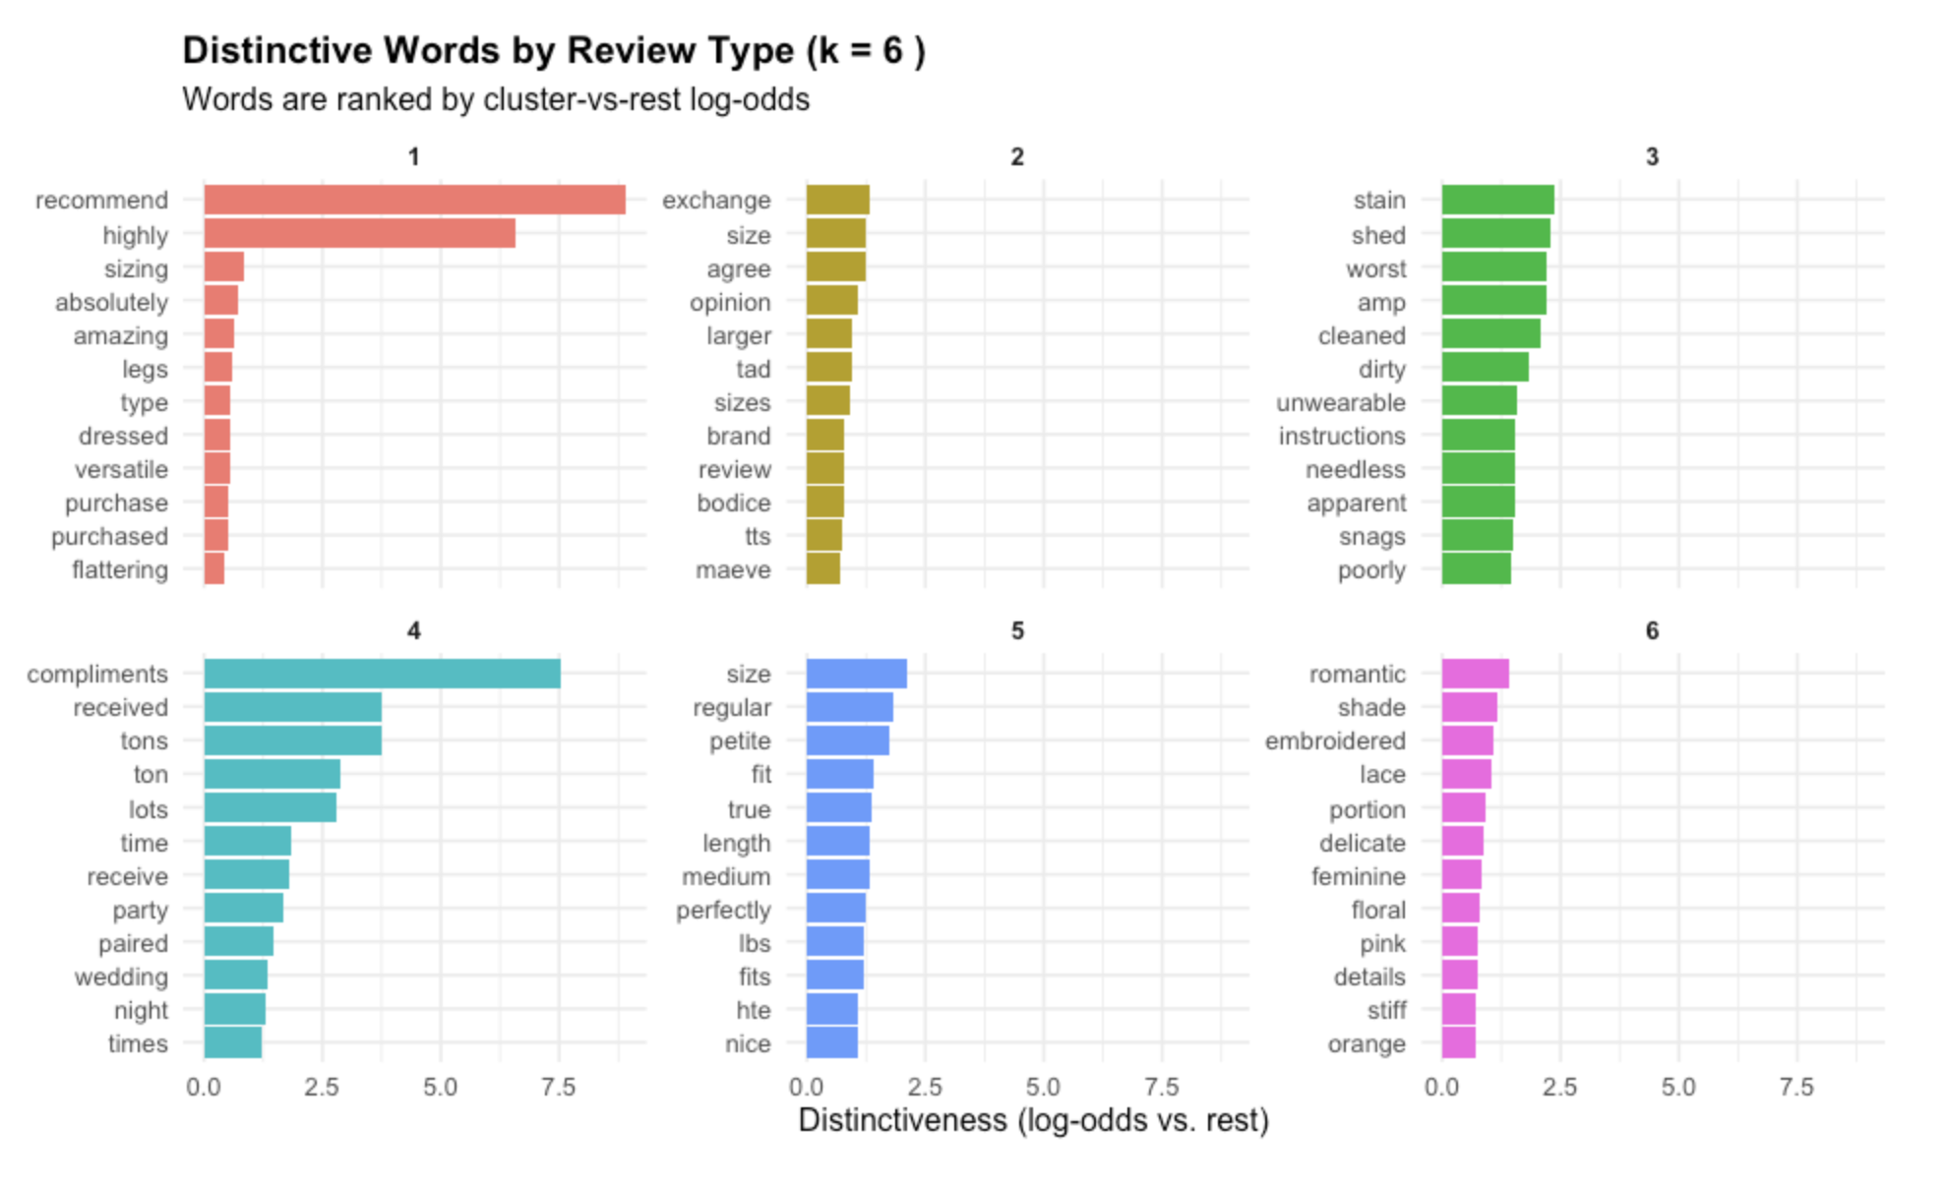

Conclusion of the Clustering Section
The clustering results show that review language is organized around recurring types of product evaluation. The strongest and most stable patterns were negative/problem-focused reviews, fit-and-sizing guidance reviews, detailed measurement or exchange reviews, style-focused reviews, and price/value-focused reviews. These groups differed in recommendation behavior, but they were not simply positive and negative clusters. Instead, they reflected different reasons customers write reviews: to complain about defects, explain fit, troubleshoot sizing, evaluate style, or judge whether an item is worth its price.

The k = 5 solution was the most useful main result because it balanced detail with interpretability. The k = 4 solution was clearer but less specific, while the k = 6 solution added nuance but became less concise. Overall, the clustering analysis supports the conclusion that clothing reviews are structured by the aspect of the product experience being evaluated, especially fit, quality, style, and value.

Logistic Regression with Train-Test Evaluation

Objective
This section examines whether review text can predict whether a reviewer recommends a product. I fit a binary logistic regression model with Recommended IND as the outcome variable. The predictors included review length, measured using char_count, and 40 latent text features derived from the TF-IDF/SVD representation of the review text.
Rating was not included as a predictor in this model. This was intentional. Because rating and recommendation status are strongly related, including rating would likely dominate the model and make it more difficult to evaluate what the written review text contributes. By excluding rating, the model focuses on whether review language itself contains patterns associated with recommendation behavior.
Logistic regression was selected because it is appropriate for a binary outcome and remains relatively interpretable compared with more complex classification models. The model allows the direction of each predictor to be examined, which is useful because the purpose of this section is not only to predict recommendation status, but also to identify broad text patterns associated with recommendation and non-recommendation.

Model Specification
The logistic regression model can be written as:

logit(P(Recommended = 1)) = β₀ + β₁(char_count) + β₂(svd_1) + β₃(svd_2) + ... + β₄₁(svd_40)

A positive coefficient indicates that higher values on that predictor are associated with a higher probability of recommendation. A negative coefficient indicates that higher values are associated with a lower probability of recommendation. Because the SVD predictors are latent text dimensions, their coefficients should not be interpreted as the effects of individual words. Instead, they represent broader patterns of language that appear across groups of reviews.

Train-Test Procedure
The train-test procedure was designed to avoid data leakage. First, the reviews were split into training and test sets using Recommended IND as the grouping variable, which kept the recommendation rate consistent across both sets. Then, the TF-IDF vocabulary and inverse document frequency values were learned only from the training reviews. The test reviews were transformed using the training vocabulary rather than being allowed to create their own vocabulary. This means that the model evaluated the test set using information learned from the training set only.

After the TF-IDF matrices were created, the training document-term matrix was row-normalized and decomposed into 40 SVD dimensions. The test reviews were then projected into the same SVD space using the SVD components learned from the training set. Finally, the logistic regression model was fitted on the training data and used to generate predicted probabilities for the test data. This makes the performance metrics more meaningful than the earlier in-sample version, because they estimate how well the model generalizes to unseen reviews.

Logistic Regression Results
The training model showed that char_count had a small but statistically significant negative coefficient. This suggests that, after controlling for text content, longer reviews were slightly less likely to recommend the product. The size of this effect was small, but the direction is consistent with the idea that more critical or mixed reviews may require more explanation.

The SVD dimensions were the strongest predictors in the model. The largest negative coefficients were associated with svd_4, svd_1, svd_32, and svd_20, while the largest positive coefficients were associated with svd_2, svd_3, svd_16, and svd_40. These results indicate that recommendation behavior is strongly associated with broad patterns in review language. However, the coefficients should not be interpreted as the effects of individual words, because each SVD dimension represents a latent mixture of co-occurring terms rather than a directly named topic.

Test Set Performance
The model was evaluated on the test set using a 0.5 probability threshold. The model correctly identified 3,558 recommended reviews and 324 not-recommended reviews. It incorrectly classified 497 not-recommended reviews as recommended and 150 recommended reviews as not recommended. The model’s overall performance was strong. Accuracy was 0.857, and the F1 score was 0.917. However, these aggregate metrics should be interpreted cautiously because the dataset is heavily imbalanced toward recommended reviews. Since approximately 82% of reviews were recommended, a model can achieve high overall performance while still struggling with the smaller not-recommended class.
The model was substantially better at identifying recommended reviews than not-recommended reviews. Recall was 0.960, indicating that the model correctly identified most reviews that actually recommended the product. Precision was 0.877, indicating that most reviews predicted as recommended were truly recommended. However, specificity was only 0.395, meaning that the model correctly identified fewer than half of the not-recommended reviews.
This uneven performance is an important limitation. The model learned meaningful language patterns associated with recommendation behavior, but it was less reliable at detecting dissatisfaction. In practical terms, the model is more effective at identifying positive recommendation patterns than at identifying non-recommendation cases.

Interpretation of Model Performance
The test-set results suggest that the model learned meaningful language patterns associated with recommendation behavior, but its performance was not equally strong for both classes. Compared with the earlier in-sample version, the train-test model had only slightly lower overall performance: accuracy changed from 0.863 to 0.857, and F1 changed from 0.920 to 0.917. This small decrease suggests that the earlier model was not dramatically overfitting. However, the train-test version is still more trustworthy because it evaluates the model on reviews that were not used during training.

The model’s main weakness is its limited ability to detect not-recommended reviews. Although it captured most recommended reviews, it classified many not-recommended reviews as recommended. This reflects the imbalance in the dataset: recommended reviews make up about 82% of both the training and test sets. Because positive reviews are so common, the model tends to predict recommendations unless the review contains especially strong negative language.

This limitation matters for how the model should be interpreted. The model is useful for identifying broad text patterns associated with recommendation, but it is less reliable as a tool for detecting dissatisfied customers. In other words, the model performs well as a general predictor of recommendation status, but it should not be treated as an equally strong classifier for both recommended and not-recommended reviews.

What the SVD Variables Mean
The variables svd_1, svd_2, and so on do not represent individual words. Instead, each SVD dimension represents a latent pattern in the review text. To interpret these dimensions, I compared the words that appeared most often on the high and low ends of each important SVD dimension. I also used the direction of the logistic regression coefficient to determine whether each dimension was associated with a higher or lower probability of recommendation.

The most important SVD dimensions in the train-test model were svd_4, svd_2, svd_1, svd_3, svd_16, svd_32, svd_20, and svd_40. These dimensions had the largest coefficient magnitudes in the logistic regression model, meaning they were the strongest text-based predictors of whether a review recommended the product. These interpretations should be treated as approximate labels rather than exact topic names. Some SVD dimensions, especially svd_20 and svd_32, combine several related language patterns and are less cleanly interpretable than the strongest dimensions. For that reason, the labels below summarize the dominant word patterns rather than defining fixed categories.

Negative Recommendation Dimensions
svd_4 was the strongest negative predictor in the model. The high side of this dimension included words such as cute, super, unflattering, expecting, returned, awful, poor, sad, and cheap. The low side included words such as wedding, stunning, perfect, event, wonderfully, perfectly, and floor. This suggests that svd_4 separates reviews that use casual or mixed style language, sometimes paired with disappointment or returns, from reviews describing formal, polished, or especially successful clothing experiences. Because the coefficient is negative, higher values on this dimension are associated with lower odds of recommendation. In practical terms, this dimension seems to capture the difference between “this looked cute but disappointed me” reviews and stronger “this was perfect for an event” reviews.

svd_1 was also strongly negatively associated with recommendation. The high side of this dimension included words such as seam, water, owned, smell, instructions, label, missing, and ruined. The low side included words such as size, true, petite, medium, perfectly, fit, stretchy, fits, and nice. This suggests that svd_1 captures care, construction, and product-defect language. Reviews high on this dimension appear to focus on problems with seams, washing, labels, odor, missing information, or damage. In contrast, the low side reflects standard fit satisfaction. Since the coefficient is negative, this indicates that care and construction complaints are associated with a lower probability of recommending the product.

svd_32 had a negative coefficient, although its word pattern is also somewhat mixed. The high side included words such as dressed, worn, casually, chest, paid, muscular, washed, awful, coloring, and dressier. The low side included words such as design, unique, bit, bell, lines, flower, sweet, appealing, and brands. This suggests that svd_32 separates practical wearability and body-related language from more explicit design-detail language. Because the coefficient is negative, the high side was associated with lower recommendation odds than the low side. However, this dimension should be interpreted cautiously because both sides include some positive language. The most defensible label is that svd_32 contrasts practical styling or body-fit discussion with distinctive design appreciation.

svd_20 was another negative predictor, but its interpretation is less straightforward than the clearest dimensions. The high side included words such as white, fabric, rayon, textured, pilling, stone, heat, black, wrap, and smooth. The low side included words such as prettier, sale, steal, waist, price, and highly. This dimension appears to contrast material- and fabric-focused language with value- or purchase-satisfaction language. Because the coefficient is negative, higher values on this dimension were associated with lower recommendation odds. However, the high side should not be read as purely negative, since some example reviews still praised fabric and quality. A more cautious interpretation is that this dimension captures reviews where material properties are central to the evaluation, and those reviews are less consistently associated with recommendation than reviews emphasizing value, price, or overall purchase satisfaction.

Positive Recommendation Dimensions
svd_2 was the strongest positive predictor in the model. The high side included words such as comfortable, compliments, booties, comfy, sandals, dressed, errands, seasons, and jewelry. The low side included words such as huge, unflattering, bust, chest, zip, petite, return, strange, and shaped. This is one of the clearest dimensions in the model. The high side reflects comfort, styling flexibility, and compliments, while the low side reflects body-specific fit problems and returns. Because the coefficient is strongly positive, higher values on this dimension are associated with much higher odds of recommendation. In other words, reviews that describe clothing as comfortable, wearable, and easy to style are much more likely to recommend the product.

svd_3 was also positively associated with recommendation. The high side included words such as true, cute, fits, regular, rompers, perfectly, bikini, super, event, and romper. The low side included words such as caught, sewn, burgundy, cheap, deep, blend, metallic, flatter, and maroon. This dimension appears to capture straightforward positive fit and cuteness language. Higher values suggest that reviewers are saying the item fits true to size, looks cute, and works for a specific occasion. Since the coefficient is positive, this kind of simple fit-and-style satisfaction is associated with higher recommendation odds.

svd_16 has a positive coefficient and appears to capture explicit recommendation language. The high side included words such as highly, recommend, black, white, ahead, combination, petite, and change. The low side included words such as material, loved, happened, online, shipping, concept, and ripped. This suggests that the high side reflects direct endorsement language, especially phrases like “highly recommend.” The low side appears more mixed, including online-shopping and material-related language that may describe disappointment or product issues. Because the coefficient is positive, reviews that explicitly express recommendation or strong approval are more likely to be classified as recommended.

svd_40 was another positive recommendation dimension. The high side included words such as black, comfy, loose, occasion, draping, split, untucked, and pattern. The low side included words such as instructions, feel, cold, water, ruined, detergent, shrunk, and chilly. This dimension seems to separate comfortable styling language from care or shrinkage complaints. The high side reflects clothing that is comfortable, loose, draped, and wearable for different occasions. The low side includes laundering, water, detergent, and shrinkage language, which suggests problems after washing or handling the garment. Since the coefficient is positive, the comfortable styling side is associated with higher recommendation odds.

Interpretation Table

Dimension | Direction in Model | Human-Readable Interpretation
svd_4 | Negative | Casual “cute but disappointing” language versus polished, formal, perfect-fit event language
svd_2 | Positive | Comfort, compliments, and styling versatility versus body-specific fit problems and returns
svd_1 | Negative | Care, seam, label, odor, and product-defect complaints versus true-size fit satisfaction
svd_3 | Positive | Positive true-to-size and cuteness language versus less flattering material/color-detail language
svd_16 | Positive | Direct endorsement and “highly recommend” language versus mixed material or online-shopping disappointment
svd_32 | Negative | Practical styling or body-fit discussion versus distinctive design-detail appreciation
svd_20 | Negative | Material- and fabric-focused evaluation versus value or purchase-satisfaction language
svd_40 | Positive | Comfortable, loose, draped styling language versus care, washing, shrinkage, and damage complaints

Main Interpretation of the SVD Results
The important SVD dimensions show that recommendation behavior is tied to specific product-experience patterns. The strongest positive dimensions were associated with comfort, fit satisfaction, styling flexibility, direct endorsement, and easy wearability. Reviews were more likely to recommend a product when they described it as comfortable, flattering, true to size, easy to style, or explicitly worth recommending.

The negative dimensions were associated with more concrete sources of dissatisfaction. These included product defects, construction problems, care or washing issues, fabric concerns, fit problems, and disappointment after purchase. Language about ruined garments, seams, pilling, shrinkage, cheap material, returns, or unflattering fit tended to appear in dimensions associated with lower recommendation odds.

These results suggest that the model is not only detecting general positive or negative sentiment. It is identifying specific forms of satisfaction and dissatisfaction that matter in clothing reviews. Positive recommendation is most closely connected to comfort, fit, styling, and endorsement, while non-recommendation is more closely connected to quality failure, maintenance problems, fit mismatch, and unmet expectations. Because SVD dimensions are latent mixtures of terms, these interpretations should remain cautious, but the high-side and low-side word comparisons make the model’s strongest text predictors more understandable.

Limitations
This project has several limitations. First, the dataset is heavily imbalanced toward positive reviews. Approximately 82% of reviews were marked as recommended, which affected the predictive model. Although the logistic regression model performed well overall, it was much better at identifying recommended reviews than not-recommended reviews.
Second, recommendation status is closely related to rating. Although rating was excluded from the logistic regression model, the strong relationship between rating and recommendation means that many language patterns may still reflect general satisfaction or dissatisfaction. Therefore, the model should be interpreted as identifying language associated with recommendation behavior, not as proving that review text independently determines recommendation decisions.
Third, the SVD dimensions are useful but difficult to interpret directly. Each dimension represents a latent mixture of words rather than a single clearly defined topic. Comparing high- and low-loading words helps make the dimensions more understandable, but the labels assigned to the dimensions remain approximate.
Fourth, k-means clustering has limitations for text analysis. K-means assumes a relatively simple geometric structure, which may not fully capture the complexity of written review language. The selected k = 5 solution is useful and interpretable, but it should not be treated as the only possible way to group the reviews.
Finally, the analysis identifies associations rather than causal relationships. The results show that certain language patterns are related to recommendation behavior, but they do not prove that specific review themes cause customers to recommend or not recommend a product.

Overall Conclusion
This project shows that women’s clothing reviews contain recurring language patterns that are closely related to recommendation behavior. The clustering analysis identified several major review types, including negative/problem-focused reviews, fit-and-sizing guidance reviews, detailed measurement or exchange reviews, style-oriented reviews, and price/value-focused reviews. These clusters differed in vocabulary, recommendation rate, average rating, review length, and feedback count, indicating that customers use reviews for different evaluative purposes.
The logistic regression analysis supported this finding from a predictive perspective. Using review length and SVD-based text features, the model predicted recommendation status with strong overall test-set performance. However, the model performed unevenly across classes. It identified recommended reviews very well, but it struggled more with not-recommended reviews because the dataset was heavily imbalanced toward positive recommendations.
Across both clustering and regression, the most important review patterns involved fit, comfort, styling, quality, value, care issues, and expectation mismatch. Recommended reviews tended to emphasize comfort, flattering fit, versatility, and direct endorsement. Not-recommended reviews were more often associated with defects, poor construction, fabric problems, washing or care issues, unflattering fit, returns, or disappointment after purchase.
Overall, the analysis suggests that review text provides information beyond structured ratings alone. Written reviews reveal the specific product experiences that shape recommendation behavior, especially whether customers are responding to comfort, fit, style, quality, value, or unmet expectations.

